***---* Assignment:-1 *---***

***Roll No: 223203***

***Name: Sohel Mehbub Mulani.***

1:write program to test Hello World.

**package** assignment;

**public** **class** assignment1hello {

**public** **static** **void** main(String[] args) {

// **TODO** Auto-generated method stub

System.***out***.println("Hello");

}

}

***OutPut:-***

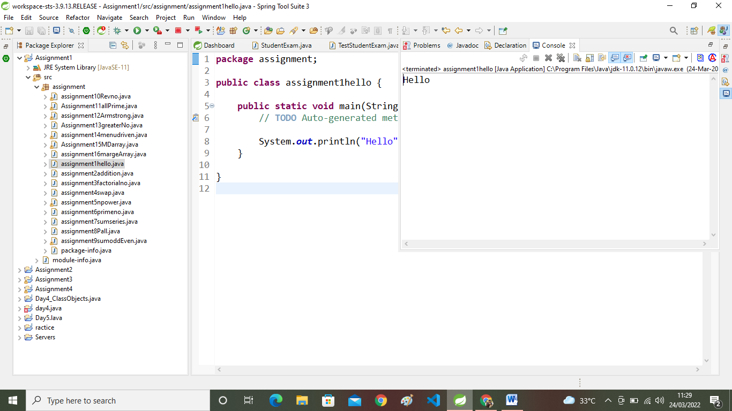

***2:Write a program to adddition of two numbers.***

**package** assignment;

**public** **class** assignment2addition {

**public** **static** **void** main(String[] args) {

// **TODO** Auto-generated method stub

**int** no1,no2,no3;

no1=20;

no2=30;

no3=no1+no2;

System.***out***.println("add="+no3);

System.***out***.println("result=no1"+"+no2"+"="+no3);

}

}

***OutPut:-***

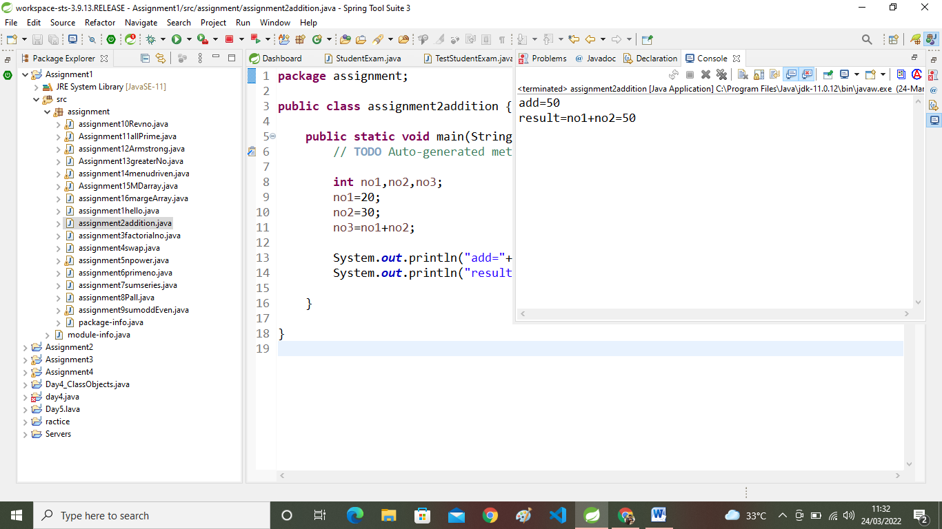

**3:Write a program to swap two numbers.**

**package** assignment;

**public** **class** assignment2addition {

**public** **static** **void** main(String[] args) {

// **TODO** Auto-generated method stub

**int** no1,no2,no3;

no1=20;

no2=30;

no3=no1+no2;

System.***out***.println("add="+no3);

System.***out***.println("result=no1"+"+no2"+"="+no3);

}

}

***OutPut:-***

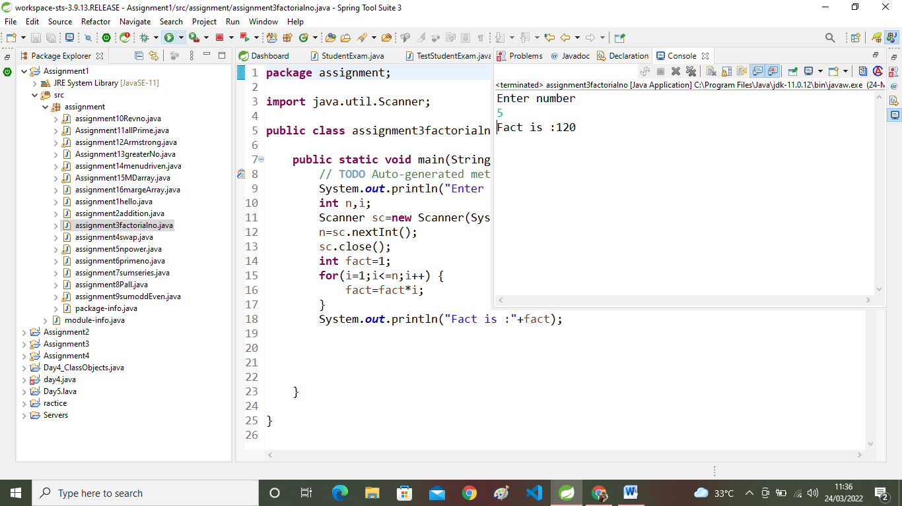

**4:Write a program to find factorial of a given number.**

**package** assignment;

**import** java.util.Scanner;

**public** **class** assignment4swap {

**public** **static** **void** main(String[] args) {

// **TODO** Auto-generated method stub

System.***out***.println("Enter frist and second num");

Scanner sc=**new** Scanner(System.***in***);

**int** num1=sc.nextInt();

**int** num2=sc.nextInt();

**int** num3;

sc.close();

num3=num1;

num1=num2;

num2=num3;

System.***out***.println("First Num:"+num1);

System.***out***.println("Second Num:"+num2);

}

}

***OutPut:-***

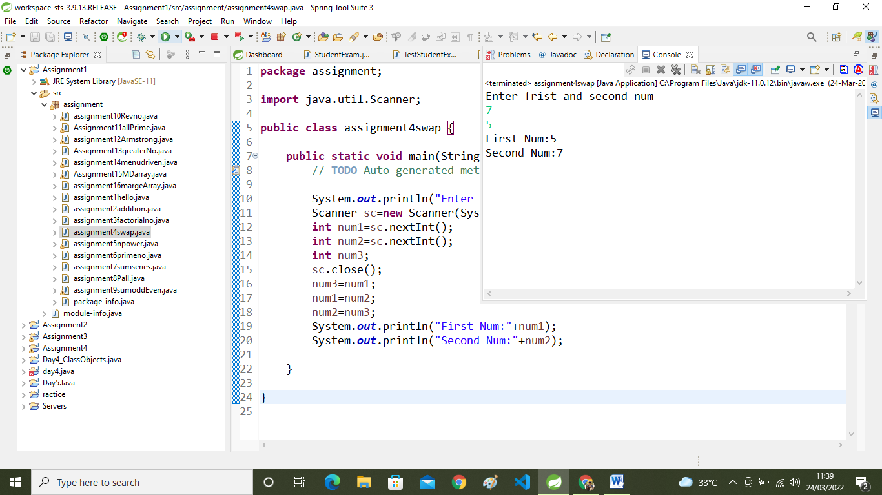

**5:Write a program to find m to the power n.**

**package** assignment;

**import** java.util.Scanner;

**public** **class** assignment5npower {

**public** **static** **void** main(String[] args) {

// **TODO** Auto-generated method stub

**int** n,p,result=1;

System.***out***.println("Frist No=");

Scanner sc= **new** Scanner(System.***in***);

n=sc.nextInt();

System.***out***.println("Enter No=");

p=sc.nextInt();

**for**(**int** i=1;i<=p;i++)

{

result=n*result;

}

System.***out***.println("power="+result);

}

}

**OutPut:-**

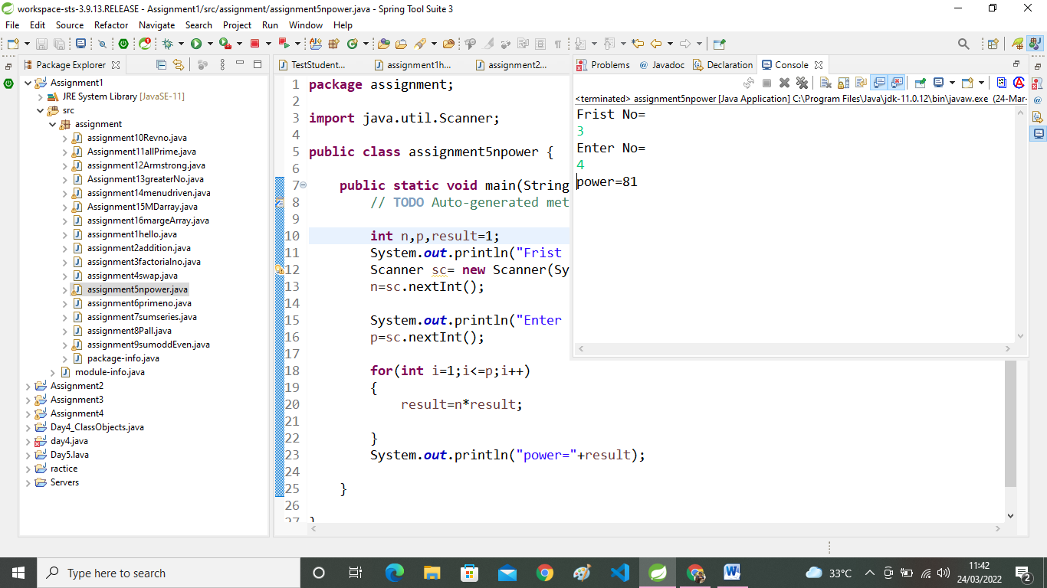

**6:Check if number is a prime number or not.**

**package** assignment;

**import** java.util.Scanner;

**public** **class** assignment6primeno {

**public** **static** **void** main(String[] args) {

// **TODO** Auto-generated method stub

System.***out***.println("Frist A Num");

Scanner sc=**new** Scanner(System.***in***);

**int** n = sc.nextInt();

sc.close();

**boolean** flag=**false**;

**for**(**int** i=2;i<n;i++) {

**if**(n%i==0) {

flag=**true**;

**break**;

}

}

**if**(flag==**true**)

System.***out***.println(" Num is not prime Number");

**else**

System.***out***.println(" Num is Prime Number");

}

}

**OutPut:-**

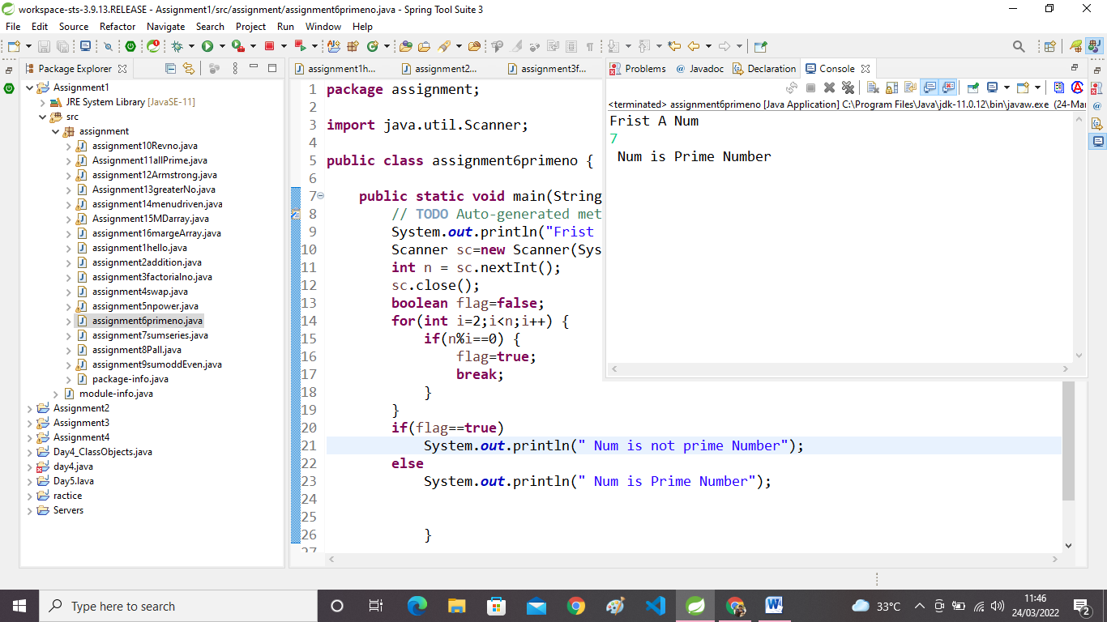

**7:Sum of series .**

**package** assignment;

**import** java.util.Scanner;

**public** **class** assignment7sumseries {

**public** **static** **void** main(String[] args) {

// **TODO** Auto-generated method stub

Scanner sc=**new** Scanner(System.***in***);

**int** n,sum = 0;

System.***out***.println("Enter Num");

n=sc.nextInt();

**for**(**int** i=1;i<=n;i++) {

sum=sum+i;

}

System.***out***.println("Total sum is:"+sum);

sc.close();

}

}

**OutPut:-**

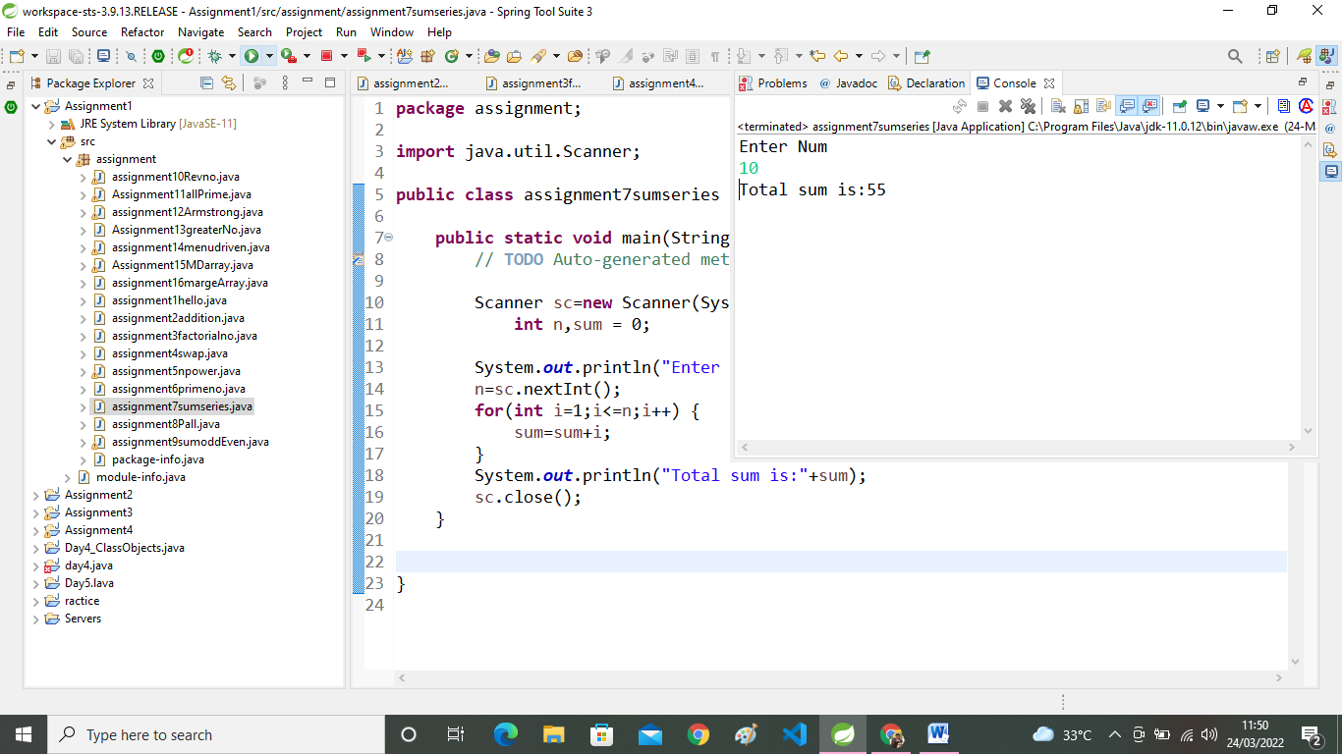

8:Check whether the number is palindrome or not?

**package** assignment;

**import** java.util.Scanner;

**public** **class** assignment8Pall {

**public** **static** **void** main(String[] args) {

// **TODO** Auto-generated method stub

**int** m,n,rev=0;

System.***out***.println("ENTER NUM TO CHECK");

Scanner sc= **new** Scanner(System.***in***);

n = sc.nextInt();

**int** a = n;

m = n;

**while** (n!=0)

{

//if use for loop i must no zero if zero end like that

m = n % 10;

rev = rev*10 + m;

n=n/10;

}

**int** b=rev;

**if** (b==a)

{

System.***out***.println("Given no is Pallimdrom ");

}

**else**

{

System.***out***.println("Given no is not Pallindrom ");

}

sc.close();

}

}

***OutPut:-***

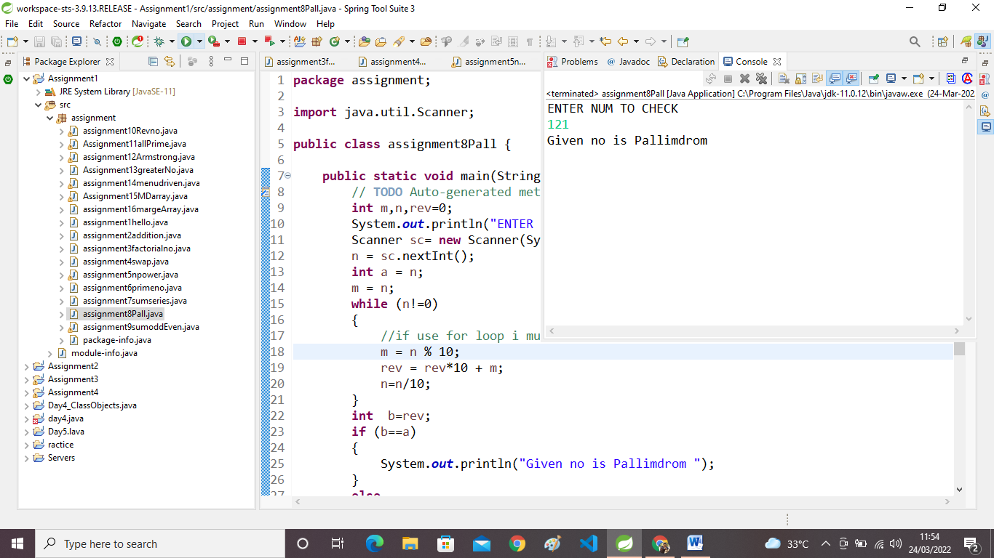

**9:Write a  program to find sum of all even and odd numbers between 1 to n.**

**package** assignment;

**import** java.util.Scanner;

**public** **class** assignment9sumoddEven {

**public** **static** **void** main(String[] args) {

// **TODO** Auto-generated method stub

Scanner sc=**new** Scanner(System.***in***);

System.***out***.println("Enter no ");

**int** n,sum=0,sum1=0;

n=sc.nextInt();

{

System.***out***.println("Number is even");

**for** (**int** i=0;i<=n;i++)

{

**if** (i%2==0) {

sum=sum+i;

}

**else** sum1=sum1+i;

}

} System.***out***.println("Sum of Even NO="+sum);

System.***out***.println("Sum of ODD Number="+sum1);

}

}

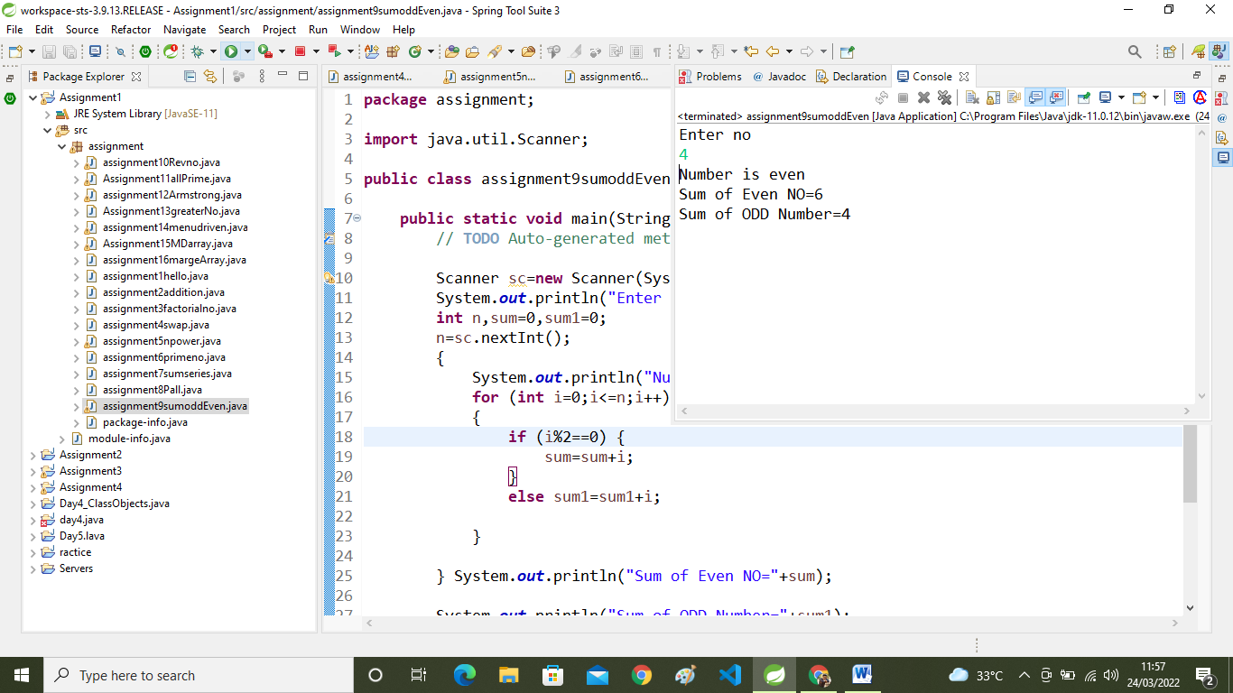

**10: Write a  program to enter a number and print its reverse.**

**package** assignment;

**import** java.util.Scanner;

**public** **class** assignment10Revno {

**public** **static** **void** main(String[] args) {

// **TODO** Auto-generated method stub

Scanner sc=**new** Scanner(System.***in***);

System.***out***.println("Enter Number=");

**int** a,sum=0;

a=sc.nextInt();

**while** (a!=0)

{

**int** b=a%10;

a=a/10;

sum=sum*10+b;

}

System.***out***.println("Rev No is="+sum);

}

}

***OutPut:-***

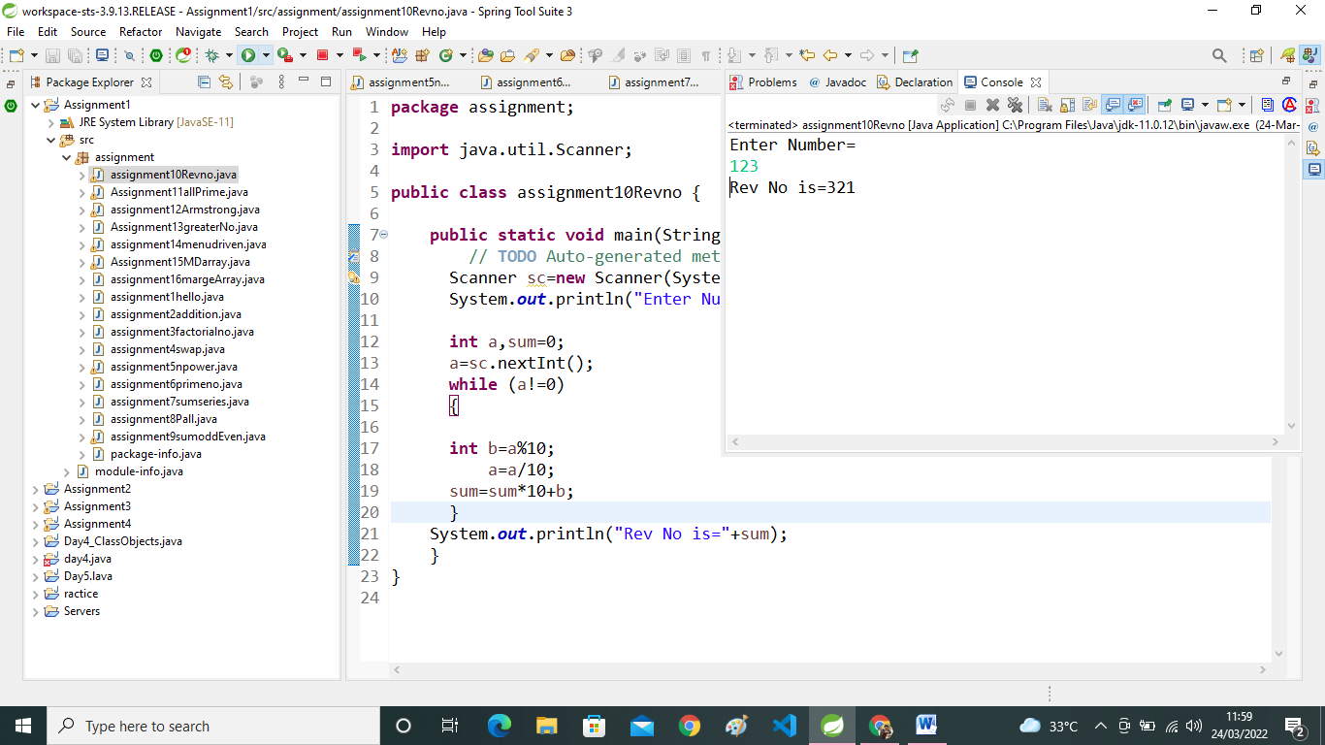

**11:Write a  program to print all Prime numbers between 1 to n.**

**package** assignment;

**import** java.util.Scanner;

**public** **class** Assignment11allPrime {

**public** **static** **void** main(String[] args) {

// **TODO** Auto-generated method stub

**int** i;**int** count = 0;

System.***out***.println("Enter a Value");

Scanner sc=**new** Scanner(System.***in***);

**int** n=sc.nextInt();

System.***out***.println("Prime number between 1 to"+n+"are");

**for**(**int** j=2;j<=n;j++) {

count=0;

**for**(i=1;i<=j;i++) {

**if**(j%i==0)

{

count++;

}

}

**if** (count==2)

System.***out***.println(j+" ");

}

}

}

***OutPut:-***

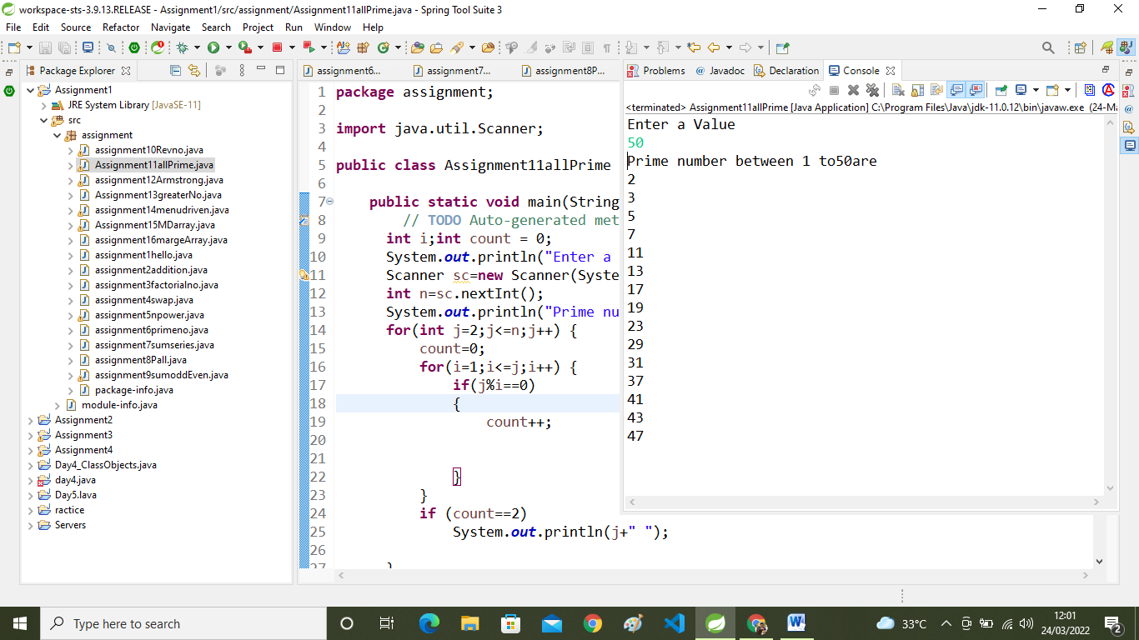

**12:Write a program to check entered number is Armstrong number or not.**

**package** assignment;

**import** java.util.Scanner;

**public** **class** assignment12Armstrong {

**public** **static** **void** main(String[] args) {

// **TODO** Auto-generated method stub

Scanner sc= **new** Scanner(System.***in***);

System.***out***.println("Enter Armstrong Number");

**int** num,a,b,sum=0;

num=sc.nextInt();

a=num;

**while** (num>0)

{

b=num%10;

sum=sum+(b*b*b);

num=num/10;

}

**if** (sum==a)

System.***out***.println("Given number is Armstrong");

**else**

System.***out***.println("Given number is Not Armstrong");

}

}

***OutPut:-***

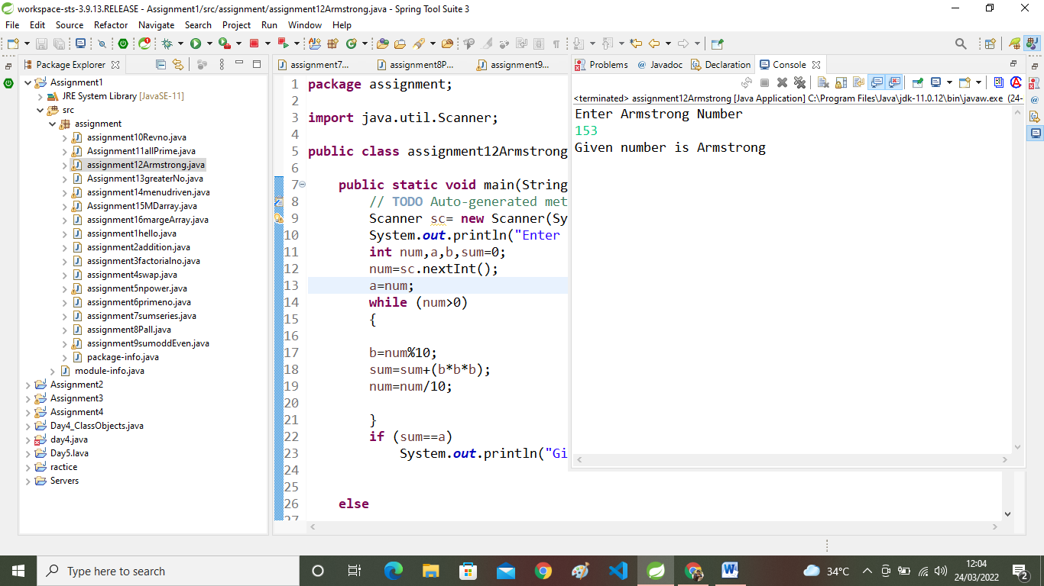

**13:Write a program to find greatest of three numbers using nested if-else.**

**package** assignment;

**public** **class** Assignment13greaterNo {

**public** **static** **void** main(String[] args) {

// **TODO** Auto-generated method stub

**int** n1=100, n2=200, n3=300;

**if** (n1>=n2 && n1>=n3)

System.***out***.println(n1+"is the largest number.");

**else** **if** (n2 >= n1 && n2 >= n3)

System.***out***.println(n2+"is the largest number.");

**else**

System.***out***.println(n3+"is the largest number.");

}

}

**OutPut:-**

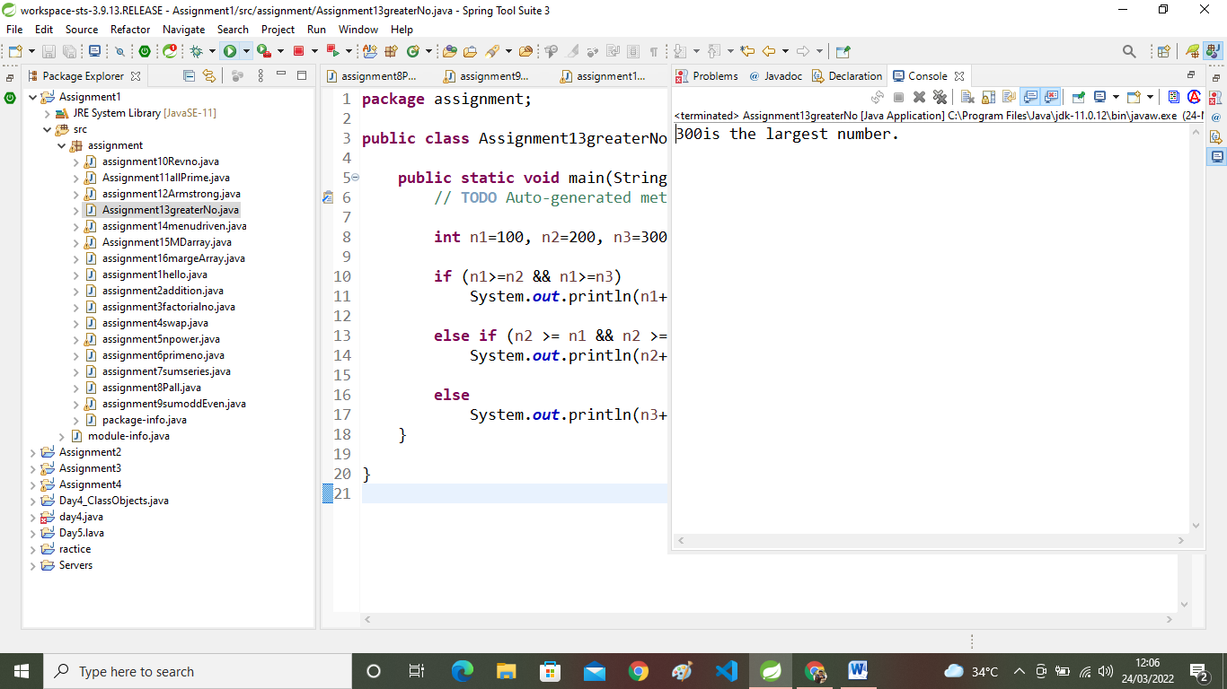

14:Create menu driven program for Pizza Shop.And display total amount,

**package** assignment;

**import** java.util.Scanner;

**public** **class** assignment14menudriven {

**public** **static** **void** main(String[] args) {

// **TODO** Auto-generated method stub

System.***out***.println("1:Large 2: Medium 3:Small 4:Bill 5:Exit");

**int** ch;

Scanner sc=**new** Scanner(System.***in***);

**boolean** status = **true**;

**int** qty;

**int** totalAmount=0;

**while**(status==**true**)

{

System.***out***.println("Enter Choice =");

ch=sc.nextInt();

**switch**(ch)

{

**case** 1:

System.***out***.println("Enter Qty for Large Pizza");

qty=sc.nextInt();

totalAmount=totalAmount+(qty*300);

**break**;

**case** 2:

System.***out***.println("Enter Qty of Medium Pizza");

qty=sc.nextInt();

totalAmount=totalAmount+(qty*250);

**break**;

**case** 3:

System.***out***.println("Enter Qty of Small Pizza");

qty=sc.nextInt();

totalAmount=totalAmount+(qty*200);

**break**;

**case** 4:

System.***out***.println("Total Amount:"+totalAmount);

**break**;

**case** 5:

status=**false**;

System.***out***.println("Thank You!!!!!!");

**break**;

**default**:System.***out***.println("invalid");

**break**;

}

}

}

}

**OutPut:-**

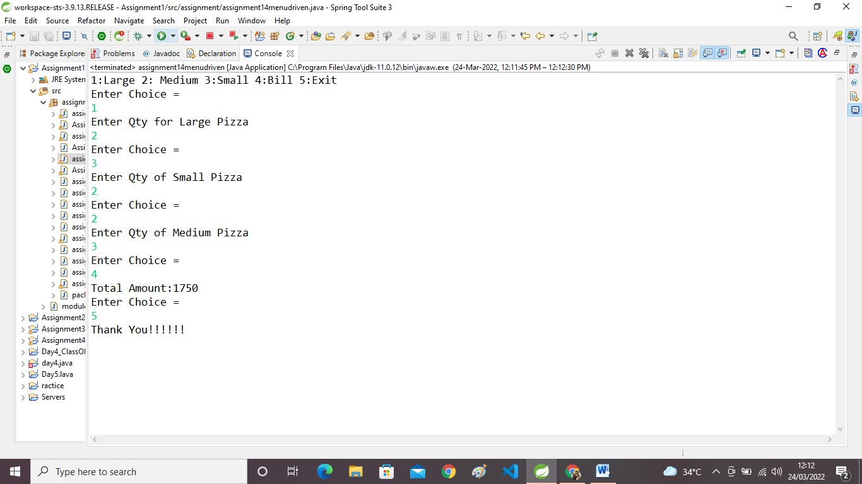

**15:Create Menu driven program for array operations.**

**package** assignment;

**import** java.util.Scanner;

**public** **class** Assignment15MDarray {

**public** **static** **void** main(String[] args) {

// **TODO** Auto-generated method stub

Scanner sc=**new** Scanner(System.***in***);

System.***out***.println("Enter Size of Array");

**int** n=sc.nextInt();

**int**[] arr = **new** **int**[n];

**boolean** status=**true**;

**while** (status==**true**) {

System.***out***.println("Enter Choise:");

System.***out***.println("1:Read Array 2:Print Array 3:Search Element IN Array 4:Revers Array 5:Even Number From Array 6:Sum of Array Element 7:Exit");

**int** ch=sc.nextInt();

**switch** (ch) {

**case** 1:

System.***out***.println("\n Read Array");

**for** (**int** i = 0; i< arr.length; i++) {

System.***out***.println("Enter Array Element");

arr[i]=sc.nextInt();

}

**break**;

**case** 2:

System.***out***.println("---Array Element---");

**for** (**int** i=0;i<n;i++)

{

System.***out***.println(arr[i]+" ");

System.***out***.println("--------------------");

}

**break**;

**case** 3:

System.***out***.println("\n Enter a Value to Check In Array \n");

**int** a1;

a1 = sc.nextInt();

**boolean** flag = **false**; {

**for** (**int** i=0;i<n;i++)

{**if** (arr[i]==a1)

flag=**true**;

//else----not needed.

//break;

}

}

**if** (flag==**true**)

System.***out***.println("---Array Element is Present---");

**else**

System.***out***.println("---Array Element is Not Present---");

**break**;

**case** 4:

System.***out***.println("Reverse Array is as Follow");

**for**(**int** j=(n-1);j>=0;j--) {

System.***out***.println(arr[j]+" ");

}

**break**;

**case** 5:

System.***out***.println("\n Even Element From Array :");

**for** (**int** i=0;i<arr.length;i++) {

**if** (arr[i]%2==0) {

System.***out***.println( arr[i]+" ");

}

}

**break**;

**case** 6:

**int** sum=0;

**for** (**int** i=0;i<n;i++) {

sum=sum+arr[i];

}

System.***out***.println("\n Sum of Even Array Element is :"+sum);

**break**;

**case** 7:

status=**false**;

System.***out***.println("----END----");

**break**;

}//switch

}//while

}

}

**OutPut:-**

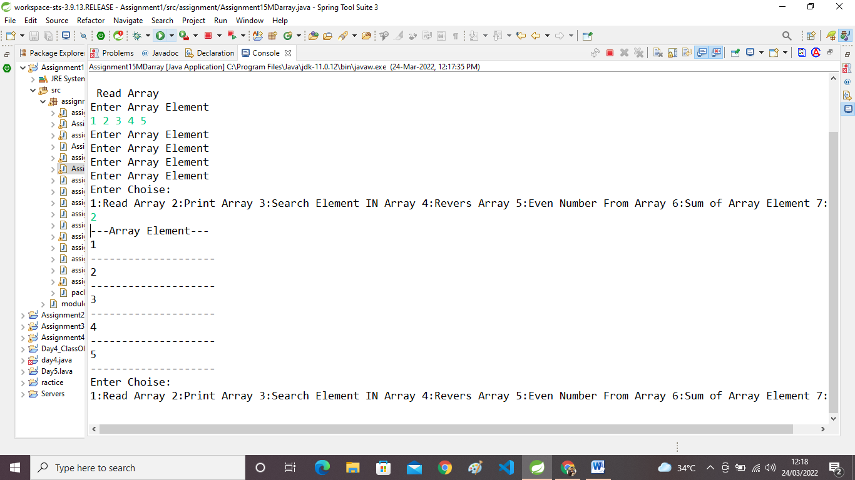

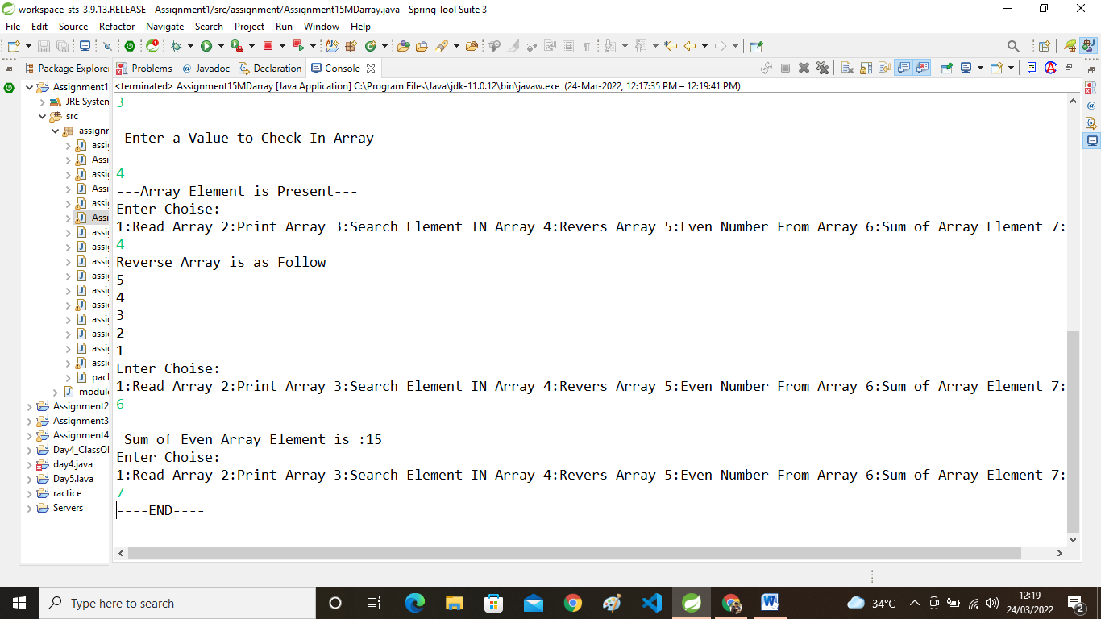

**16:read two int array...and store both in third array and display third array.**

**package** assignment;

**public** **class** Assignmeent16Merge {

**public** **static** **void** main(String[] args) {

// **TODO** Auto-generated method stub

**int**[]arr1={1,2,3};

**int**[]arr2= {5,6,7,8,9};

**int** arr1_len=arr1.length;

**int** arr2_len=arr2.length;

**int** arr3_len=arr1_len+arr2_len;

**int**[]arr3=**new** **int**[arr3_len];

**for**(**int** i=0;i<arr1.length;i++)

{

arr3[i]=arr1[i];

}

**for**

(**int** i=0;i<arr2.length;i++)

{

arr3[arr1.length+i]=arr2[i];

}

System.***out***.println("After Merge array Element are:");

**for**(**int** i=0;i<arr3_len;i++) {

System.***out***.println(arr3[i]);

}

}

}

**OutPut:-**

